** Install driver of USB-to-Serial Converter

1. Programing H8 Board (3048F) with GCC Developer Lite:
   1. Install “GDLFull1.5.0.18SP1”.
   2. Start a new project:

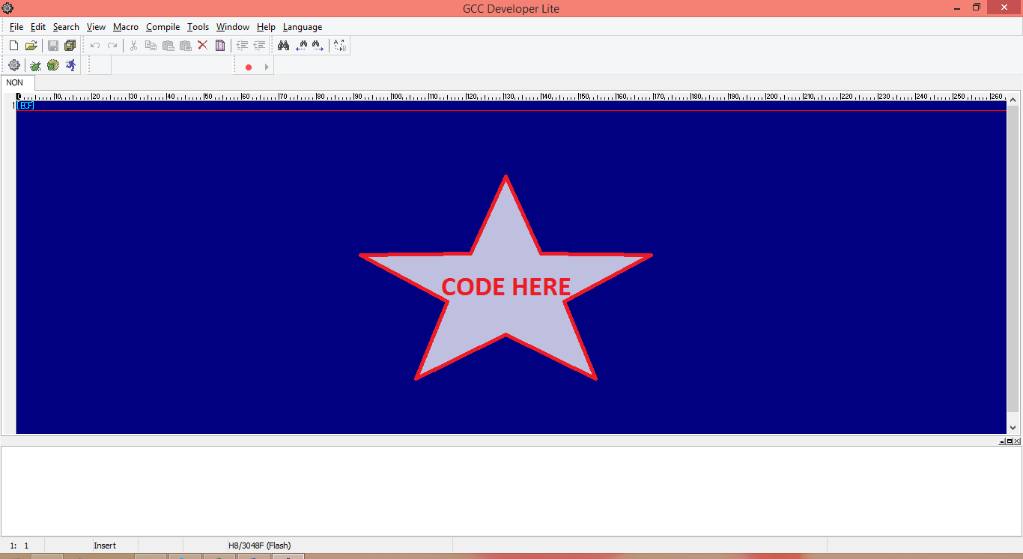

* 1. Setting:

Tools -> Compile Option

SettingList: H8/3048F (Flash).

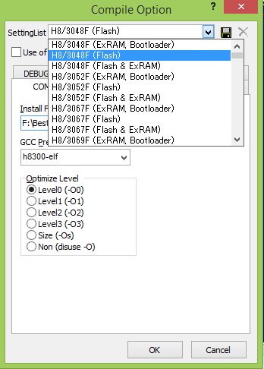

* 1. Build project

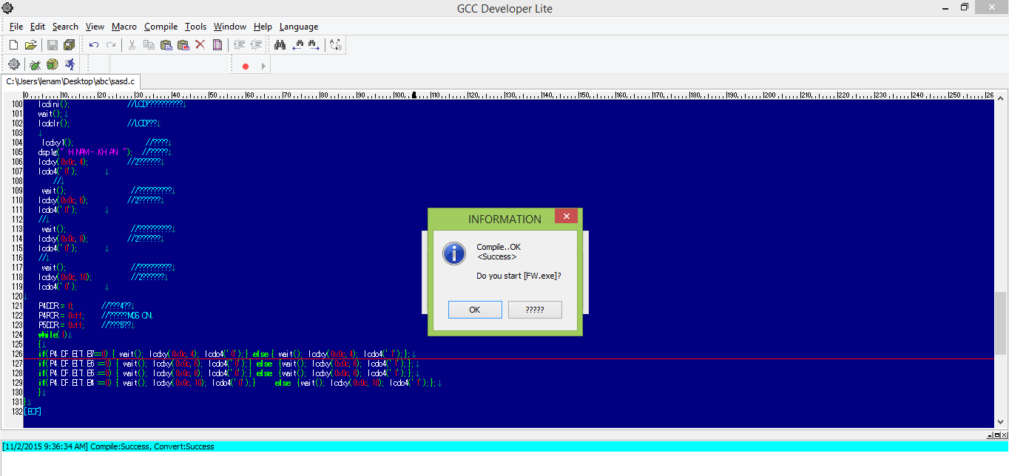F9 or click 

Click OK and 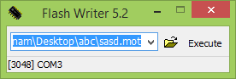 will pop up.

Setting Flash Writer to flash program to H8 board:

* Hit “open” symbol -> choose *.mot file of the project. (*.mot file directory will be available when Flash Writer pops up)
* Double click on area near “[3048] COM3” (picture above)

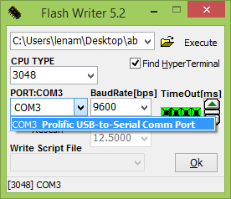

BaudRate: 9600

PORT: choose a port connected to your computer via usb-COM cable.

* Before Executing:

**Enable Write Mode** using Switch of the Board. **Then** power the board.

* Execute.

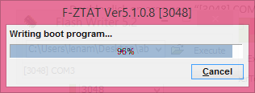

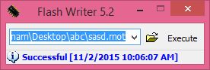

Re-power the board if it failed to write.

* Enable Run Mode using Switch of the Board. **Then** re-power the board.